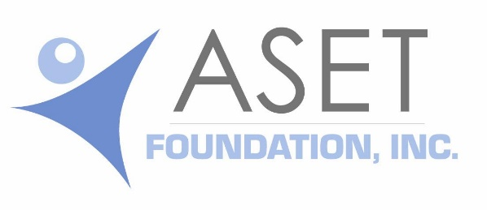

Knott Educational Lecture Program - Request for Lecturer

This form can be submitted electronically by following the format and submitting the required information as requested.

Contact Information

Name of Chapter or Society _________________________________________ Date _______
Name of Chapter/Society Representative/Contact _____________________________________
Address ______________________________________________________________________
Work Phone (_____)_______________________ Cell Phone (_____)___________________
Email ___________________________________

Meeting Information

Meeting Dates ________________________________Lecture Date/Time __________________
Meeting Location/Facility _________________________________________________________
Address ______________________________________________________________________
Phone ________________________________________________________________________
If the hosting city does not have a major airport, please indicate the nearest major city and airport. _______________________________________________________________________
If the meeting is not being held in a hotel, please provide information for the lecturer accommodations/hotel reservation. Hotel ___________________________________________
Address ______________________________________________________________________
Phone ________________________________ ______________________________

Expected number to attend the meeting ________________

Lecture Topics/Information

List your preference for lecture topics:

First choice ______________________________________________
Second choice ______________________________________________
Third choice ______________________________________________

Continue to the next page

Available audio/visual aids:
☐ LCD data projector ☐ Flip charts
☐ Wi Fi/Internet Connection ☐Laser pointer ☐Wireless mouse
☐Other _________________

Only one Knott Lecturer can be funded each fiscal year. Chapters and societies selected to host the Knott Lecturers will be chosen according to the following:
- The order in which applications are received.
- How recently the chapter or society has hosted a Knott Lecturer.
- Completed Knott Lecture Request Form submitted by the appropriate deadlines.

Briefly state why your chapter/society would like to host a Knott Lecturer.

_____________________________________________________________________________
_____________________________________________________________________________
_____________________________________________________________________________
___________________________________________________________________________________________________________________________________________________________________________________________________________________________________________________________________________________________________________________________________________________________________________________________________________________________________________________________________________________________________________________________________________________________

Chapter and society meetings scheduled from Sept. 1 to August 31 of the following year are eligible for the Knott Lecturer Program. The application deadline is June 1 yearly.

Contact for questions:
Linda Kelly, MS, R.EEG/EP T, R NCS T, FASET, CSSGB
816-931-1120, ext. 108
Linda@aset.org

